Booknest :Where Stories Nestle

(A Smart Digital Bookstore Platform)

INTRODUCTION

1.1 Project Overview:
_誑_·¡^· Project Title:

Booknest : Where Stories Nestle

_]궃H Project Overview:
Booknest
is an intelligent, user-centric online bookstore designed to modernize the way readers discover, purchase, and manage books. The platform aims to serve book lovers, casual readers, and academic learners by offering a wide collection of physical and digital books with enhanced features such as smart recommendations, wishlist management, user reviews, and admin-level controls.

´"’虇●虊 Objectives:

- Provide a seamless digital interface for browsing and purchasing books.

- Offer user and admin portals with respective functionalities.

- Enable wishlist creation, cart handling, and secure checkout.

- Offer book categorization by genre, author, and popularity.

- Ensure a responsive and mobile-friendly experience.

_곻□¿ Key Features:
- User registration/login (with authentication).
- Dynamic book listings and filtering.

- Book details with image and description.

- Admin controls: Add/Edit/Delete books.

- Order placement and tracking.

蹫+ Target Users:

- Students.

- Avid Readers

- Librarians and institutions

- Bookstore owners (admin role)

’\‘z Technology Stack (Suggestive):
- Frontend: React.js, Bootstrap
- Backend: Node.js with Express
- Database: MongoDB (Mongoose)
- Authentication: JWT or Firebase Auth
- APIs: REST APIs for books, users, orders, wishlist

#/⬛ Expected Outcome:
A well-designed and user-friendly bookstore application that supports browsing, wishlist management, ordering, and administration through secure and scalable technologies.

1.2 Purpose:
´虊’虇●" Purpose of the Project
The purpose of the Booknest platform is to offer a complete digital bookstore experience that is intuitive, functional, and responsive. It removes the inconvenience of physical browsing and simplifies book discovery, purchase, and review.

IDEATION PHASE

2.1 Problem statement:
Traditional bookstores and many online platforms lack personalization and structure. Users often find it difficult to:
- Locate books relevant to their interests
- Manage wishlists efficiently
- Track orders or reviews

- Administer content (for sellers)
There is a need for a robust digital bookstore platform with smart search, secure management, and clear navigation.

2.2 Empathy Map canvas:
*˛C Empathy Map Canvas: (User: Reader) Says:
- "I want a quick way to find a specific book."
- "I need reviews before I buy."

Thinks:
- "Is this price fair?"
- "Will I get delivery on time?"

Does:
- Searches by title or genre
- Adds items to wishlist/cart

Feels:
- Overwhelmed by cluttered UIs
- Frustrated with slow loading or irrelevant results

˙Q• User Needs (From Empathy Map)
- Clear search and filters
- Wishlisting
- Secure payments
- Mobile support

2.3 Brainstorming :
Features Discussed:
- Search/filter books by genre, author, price
- Admin dashboard
- Wishlist, reviews
- Order management
- Book image upload and preview
- Notification system (optional future scope)

REQUIREMENTS ANALYSIS

Journey Map
    - User Management:
      - Register/Login with email (JWT Auth)
      - Profile editing

Book Listing & Details:
      - View all books with cover images, price, genre
      - View book detail page

Wishlist & Cart:
      - Add/remove books to wishlist
      - Add/remove books to cart
      - Move items from wishlist to cart

Order System:
      - Place an order
      - View order history

Admin Panel:
      - Add/edit/delete book listings
      - View user orders

Solution Requirements
- Usability: Mobile-responsive, clean UI.
- Performance: Fast API responses.
- Security: JWT-based Auth.
- Scalability: Handle large collections.
- Maintainability: Modular codebase.

  - Data Flow Diagram
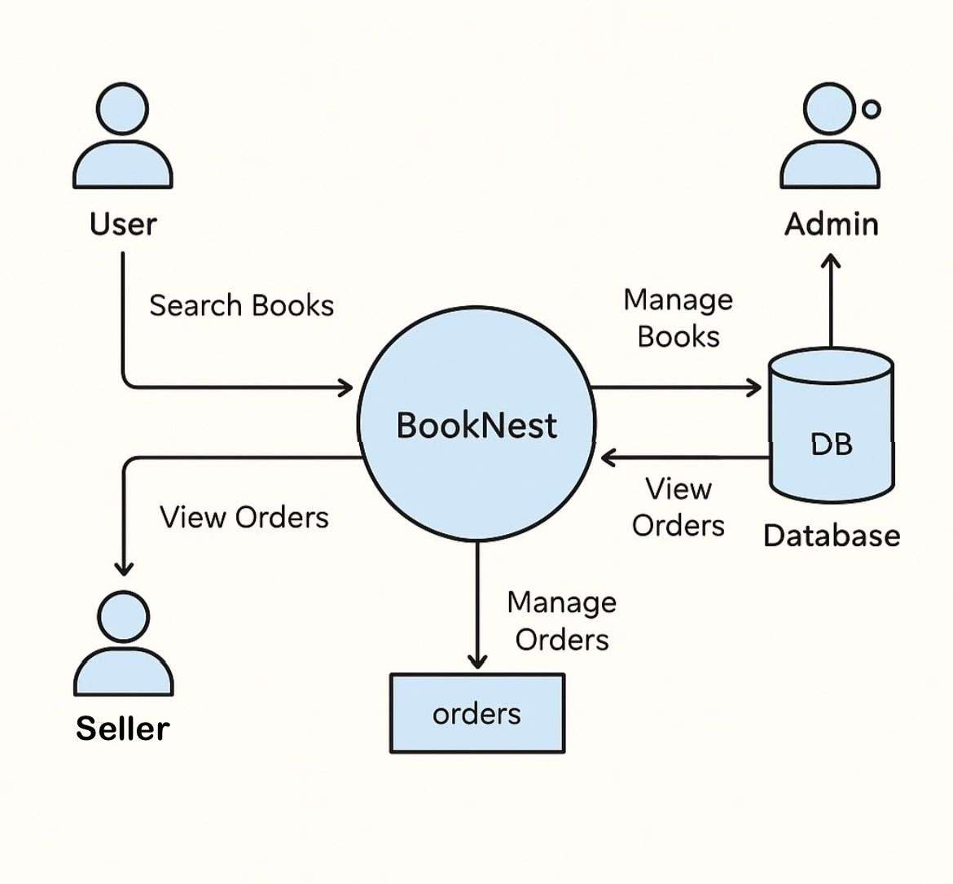

  - Technology Stack

Layer | Technology Used
Frontend | React.js, TailwindCSS
Backend | Node.js, Express.js
Database | MongoDB with Mongoose
Authentication | JWT
Hosting | Vercel (Frontend), Render/Heroku (Backend)

PROJECT DESIGN

Problem-Solution Fit
Problem: Users lack a smart, fast, and categorized book shopping experience.
Solution: Booknest delivers a filtered, admin-manageable bookstore with wishlist, cart, and order history.

Proposed Soultion
The proposed solution is to build a digital bookstore application that enables users to browse, search, and manage book purchases efficiently. The system will incorporate user authentication, an admin dashboard, and essential features like wishlist and cart handling.
Through a responsive frontend and a robust backend API, users and administrators will interact with the system seamlessly. This architecture ensures scalability, maintainability, and future extensibility of the platform.

Solution Architecture
- Frontend: React app with protected routes
- Backend: Express server with RESTful API
- Database: MongoDB stores users, books, orders
- Auth: JWT Token-based middleware for secure access

Diagram (Textual Representation)
[Frontend (React)] ⇄ [Backend (Express)] ⇄ [MongoDB]
↓ ↑
[User] [Admin Auth Middleware]

PROJECT PLANNING & SCHEDULING
  - Project Planning:

Week | Tasks
1 | Requirement Analysis, UI Wireframe, DB Schema
2 | Frontend Setup: Login, Register, Home, Book List
3 | Backend APIs for users, books, wishlist
4 | Cart & Order functionality, Admin panel setup
5 | Testing, Deployment (Vercel + Render), Report & PPT

FUNCTIONAL AND PERFORMANCE TESTING

Performance Testing
Performance was assessed by simulating a large number of book entries:
- Book Load Performance: Confirmed that the book listing page remains responsive with hundreds of book entries.
- API Response Time: Measured response times under load using tools like Postman and browser DevTools.

Unit Testing
Unit testing was performed for individual components such as:
- Form validation: Ensured that all required fields were properly validated before submission, preventing empty inputs or invalid formats.
- Add to Cart: Verified that the correct book is added to the user's cart and the cart state updates accordingly.

Integration Testing
Integration testing focused on the interaction between frontend and backend:
- API Routes: Tested routes like /item, /wishlist, /orders to ensure accurate data exchange.
- UI Components: Verified that React components properly render the data fetched from APIs and handle loading or error states.

Functional Testing
Functional testing validated complete flows:
- Book Search: Users can search for books by title or genre.
- Wishlist Management: Adding/removing items from wishlist works as expected.
- Order Placement: End-to-end ordering from cart to confirmation is functional.

RESULTS
  - Output Screenshots:

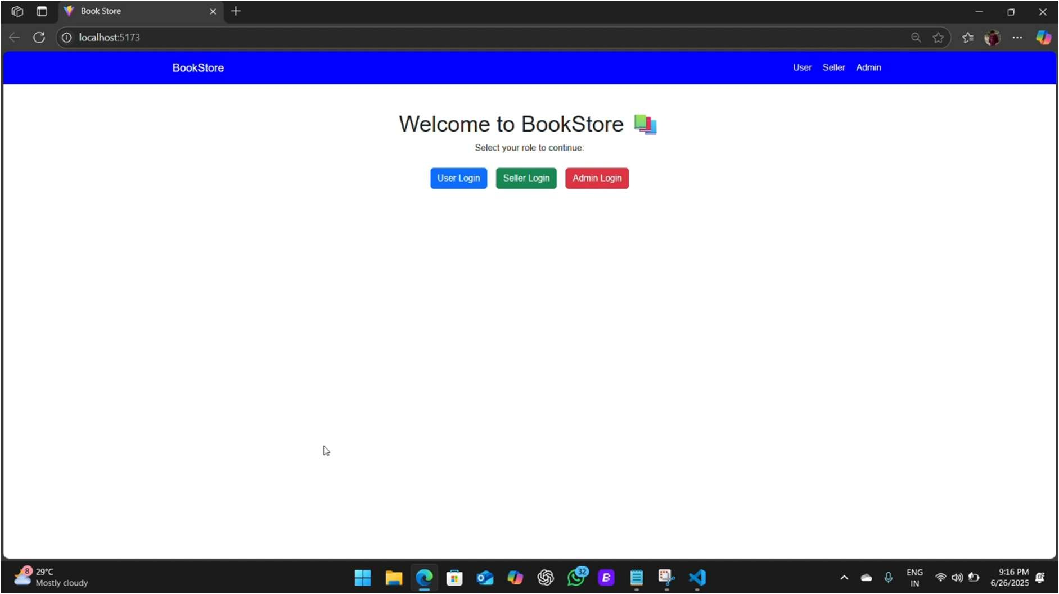

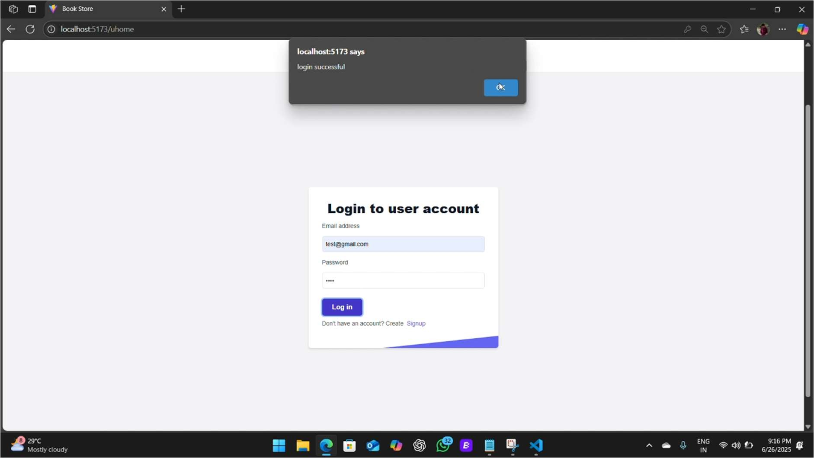

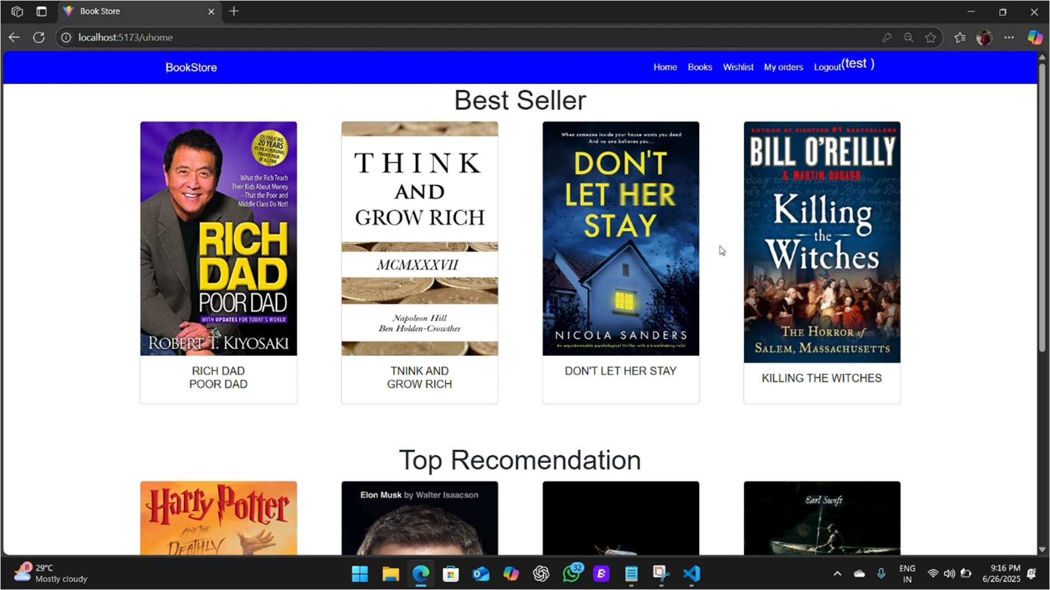

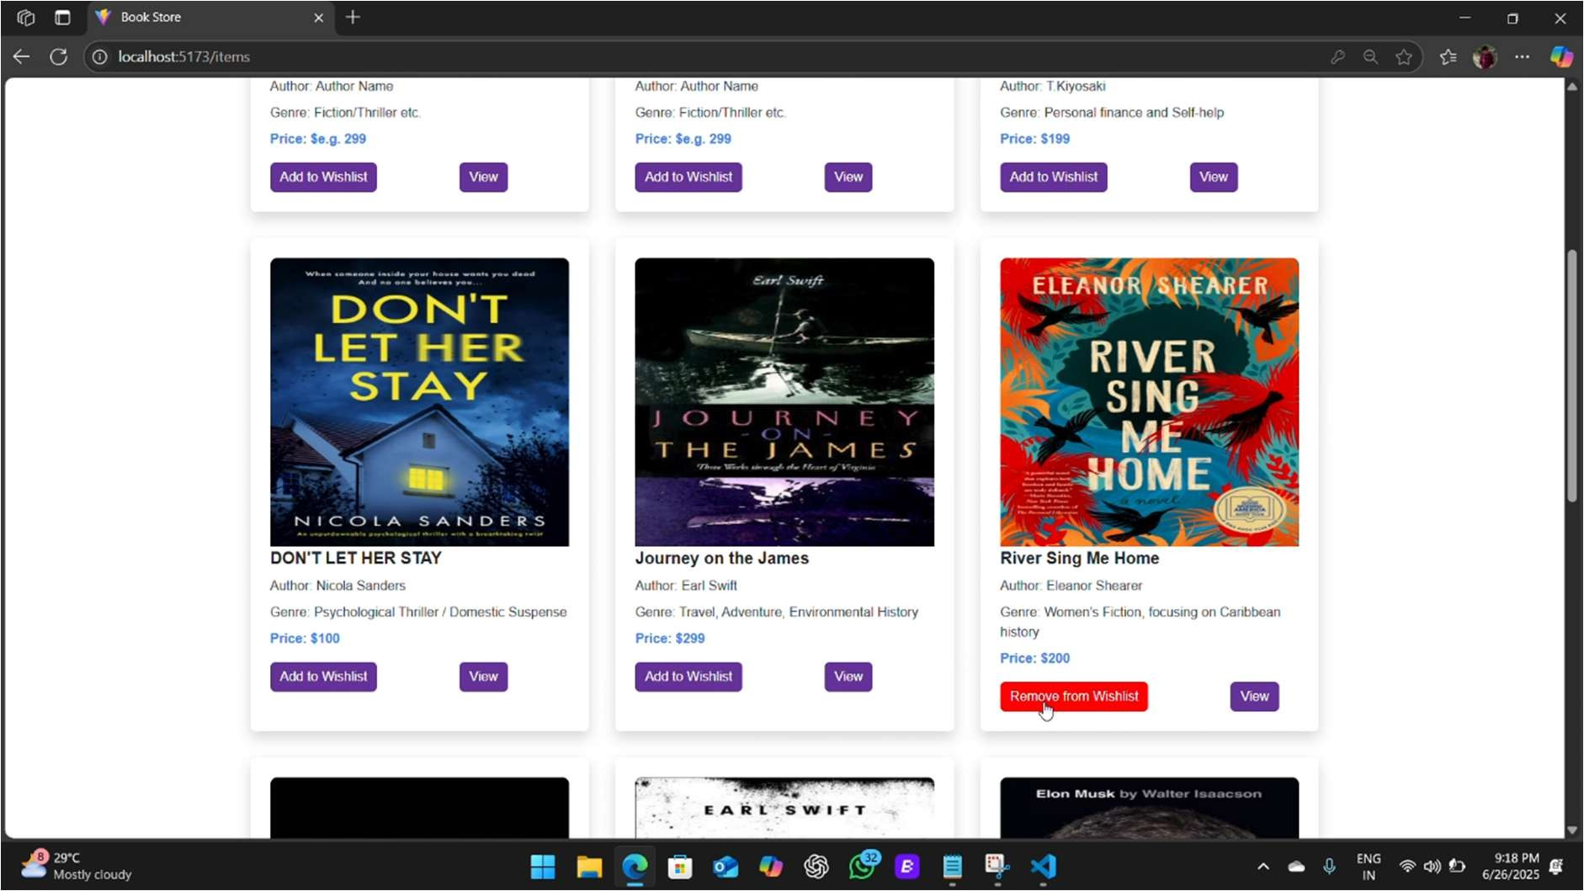

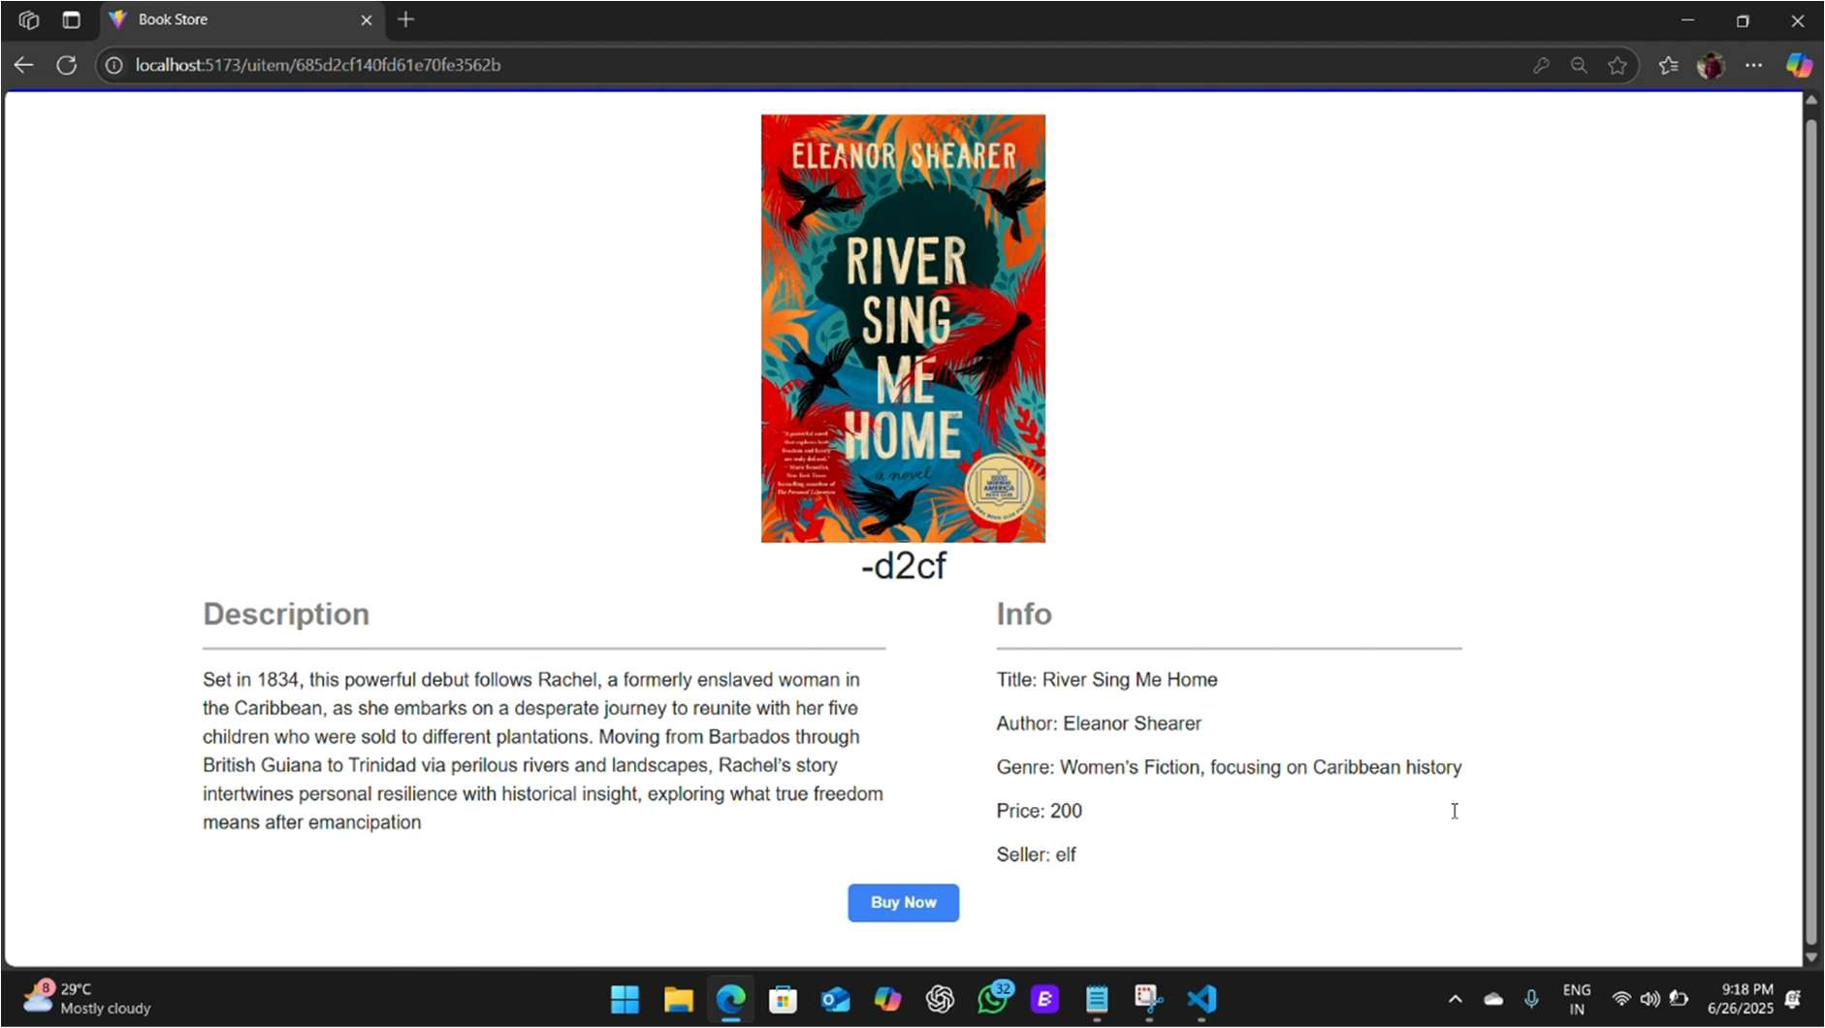

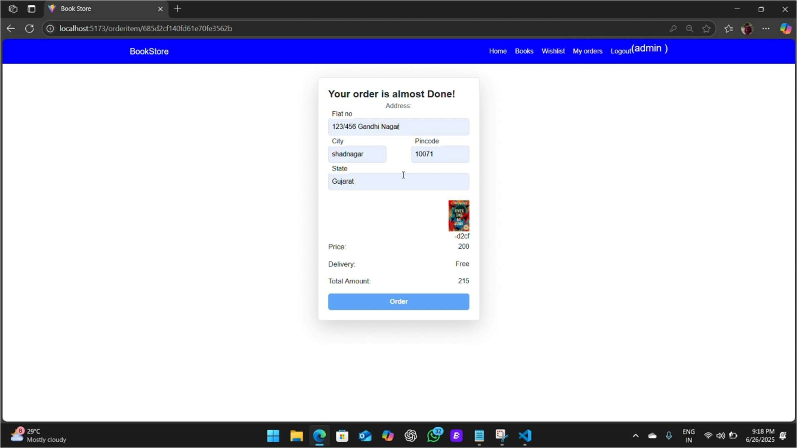

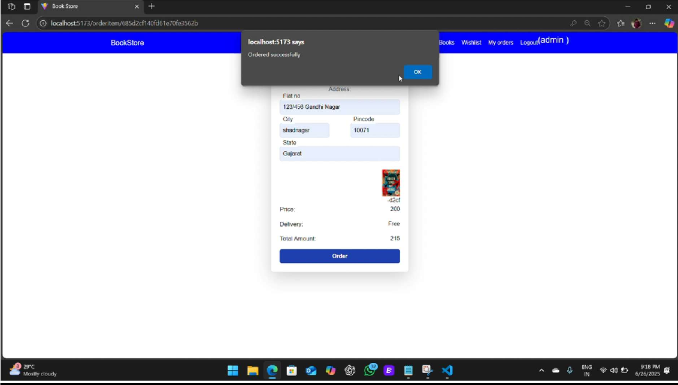

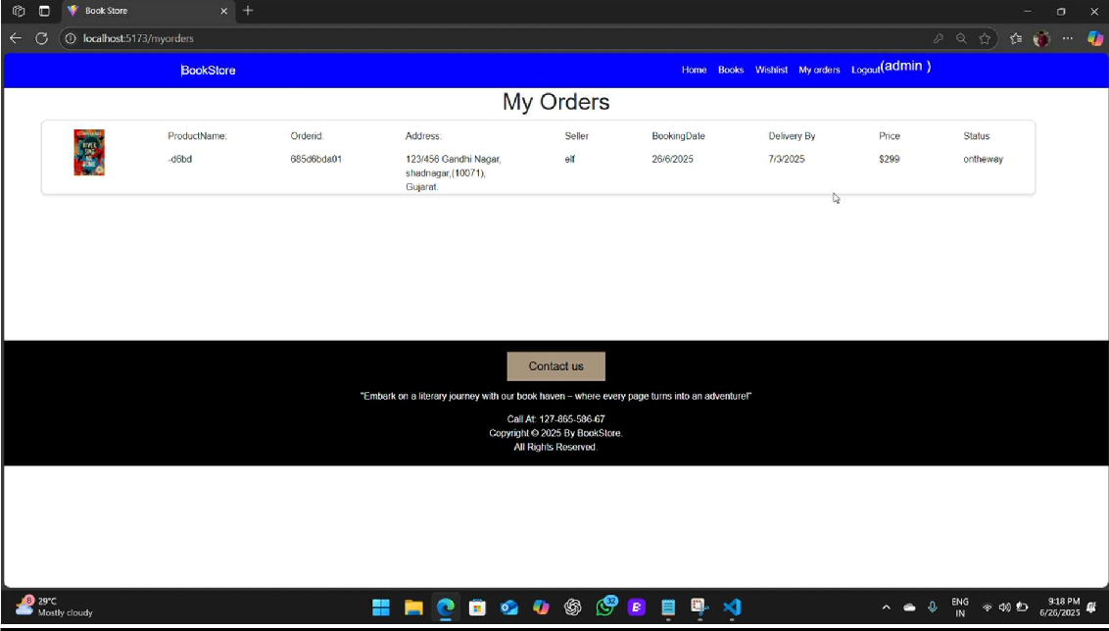

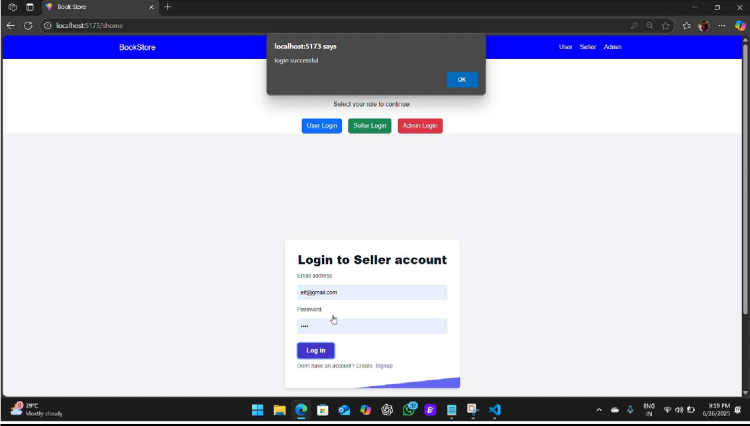

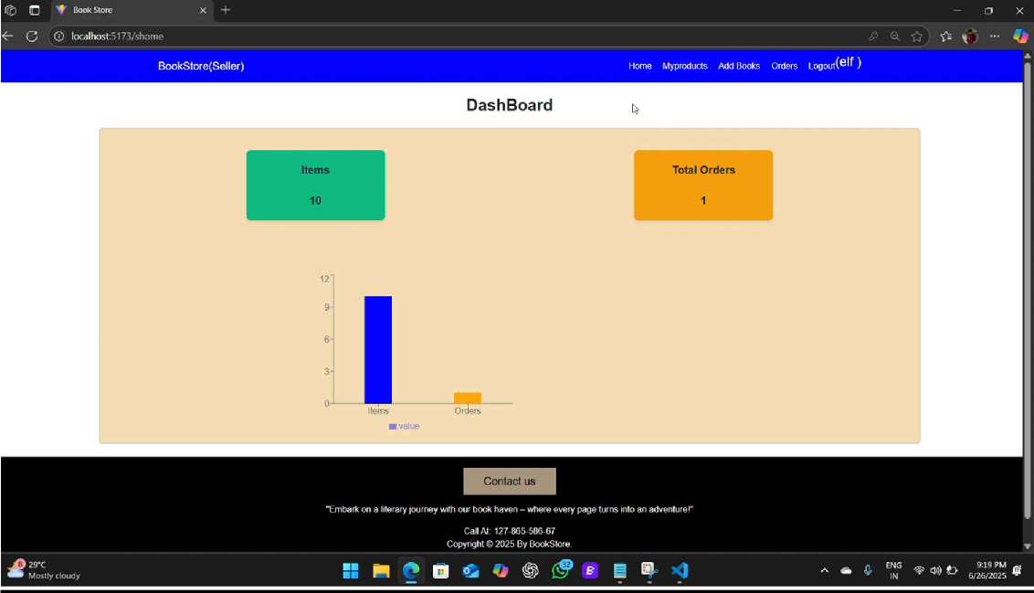

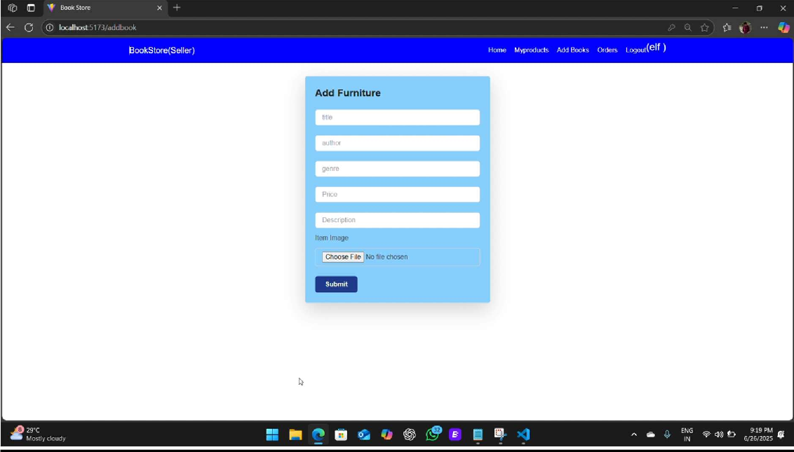

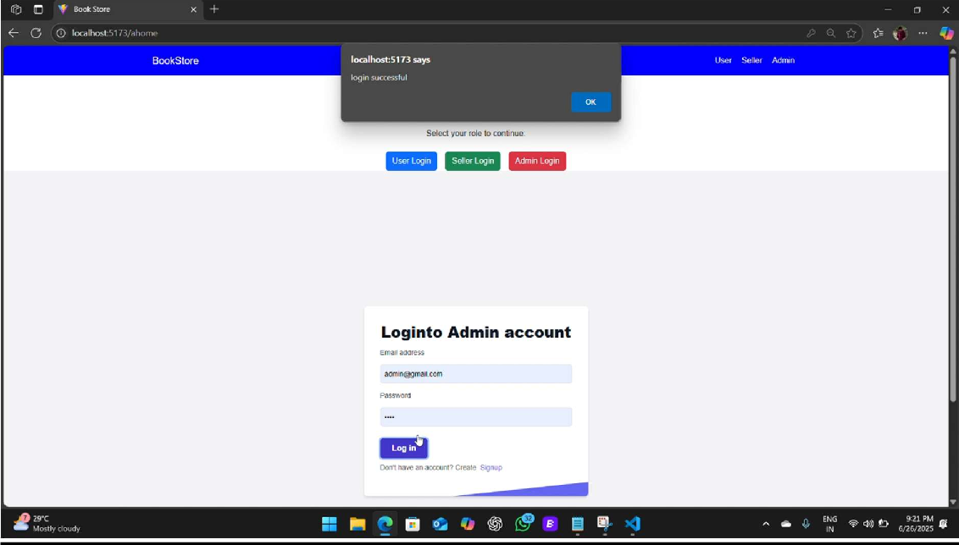

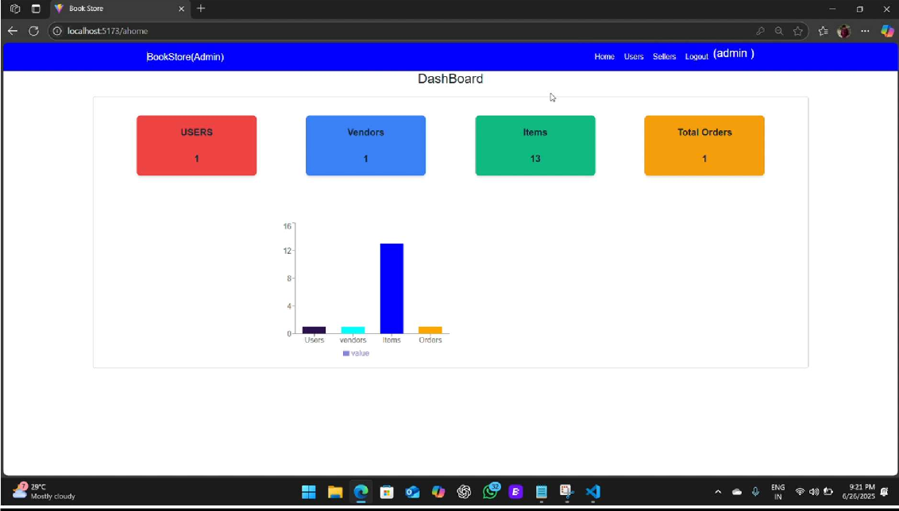

ADVANTAGES & DISADVANTAGES

⬛ 8.1 Advantages
- User-Friendly Interface: Clean and intuitive design that simplifies user navigation.
- React Frontend: High performance and fast page loads due to the efficient React framework.
- Secure Authentication: JWT provides secure and scalable authentication for both users and admins.
- Scalability: MongoDB schema allows flexible expansion of book listings, users, and orders.

+ 8.2 Disadvantages:
- No Payment Gateway: Purchases are simulated without real-time payment integration.
- Manual Admin Moderation: Book and order management require manual updates by admin.
- Limited Personalization: Recommendation engine and rating systems are not yet implemented.

CONCLUSION
Booknest proves to be an effective digital bookstore application that combines modern web technologies with clean design and essential e-commerce features. The project demonstrates a comprehensive understanding of full-stack development, including frontend design, backend API integration, secure authentication, and data management.
Its modular structure and clear architecture enable smooth navigation, scalability, and future adaptability. By delivering critical features like user account management, dynamic book listings, wishlist/cart functionality, and admin controls, it lays the groundwork for a complete e-commerce solution in the literary domain.
Furthermore, the platform's responsiveness and seamless performance across devices reflect good UI/UX practices. With room for future integration of real-time payments, recommendation engines, and AI-enhanced personalization, Booknest stands as a solid foundation for both academic success and potential real-world or entrepreneurial implementation.

FUTURE SCOPE

Online Payment Gateway
Integrate Razorpay, Stripe, or PayPal APIs to enable real-time transactions, providing a complete e-commerce experience.

Reviews & Ratings
Allow users to leave reviews and rate books. This improves engagement and helps others in decision-making.

Real-Time Chat Support
Add a live chat feature (e.g., via Socket.io or a third-party widget) to support users with their inquiries instantly.

AI-Based Recommendations
Use machine learning to recommend books based on user behavior, previous orders, and genre preferences.

Subscription/Plan Features
Introduce premium subscriptions with benefits like early access to new books, free delivery, or curated reading lists.

APPENDIX
Github : https://github.com/Bindu-806/Booknest
Project demo link: https://github.com/Farukh444/Book_nest/tree/my-new-branch/video

